LAB 1
EXERCISE 1 and EXERCISE 2 - isAntique() method
File: Class.java

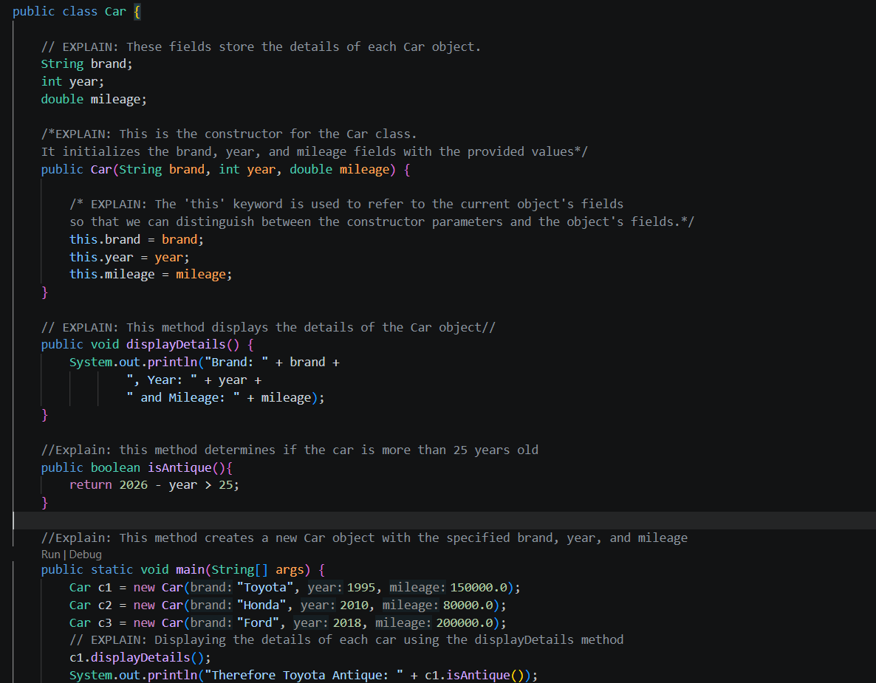

Output:
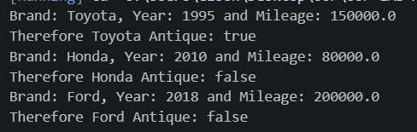

EXERCISE 3
File: Rectangle.java
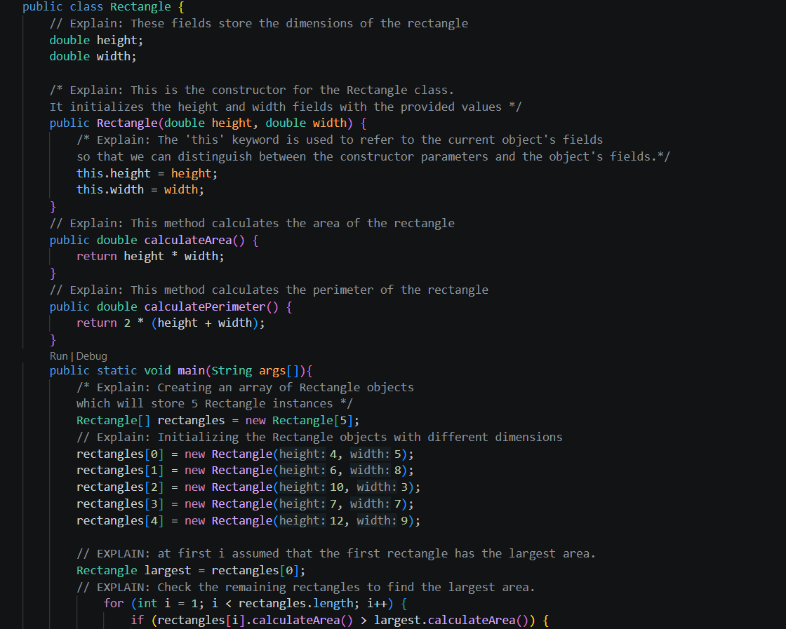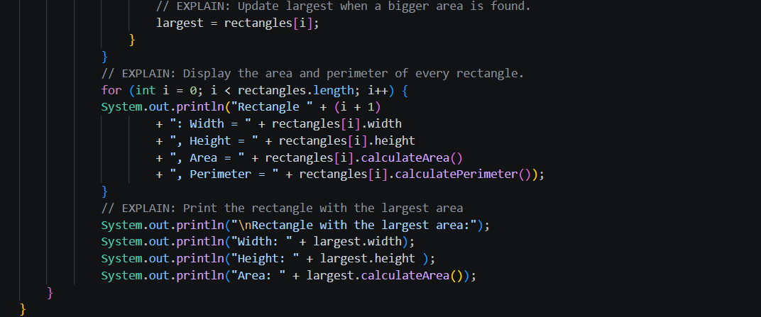
Output:
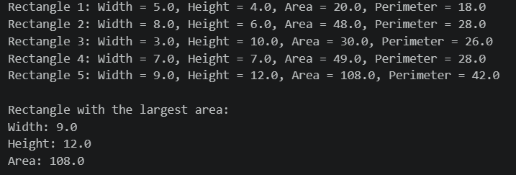

EXERCISE 4
File: Rectangle.java - Class RectangleAliasDemo
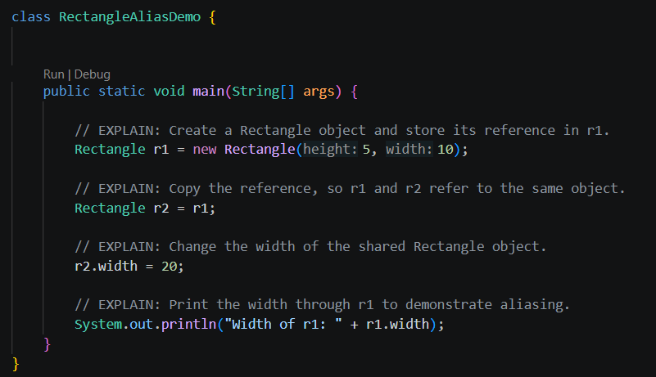
Output:
Explanation of the Result:
The statement Rectangle r1 = new Rectangle(5, 10); creates a Rectangle object with a width of 5 and a height of 10. The variable r1 stores a reference to this object.
The statement Rectangle r2 = r1; copies the reference from r1 to r2. It does not create a new Rectangle object. Therefore, both r1 and r2 refer to the same object.
When r2.width = 20; is executed, the width of that shared object changes to 20. Consequently, printing r1.width also displays 20.0.
This behaviour is known as aliasing. It demonstrates that assigning one object reference to another does not copy the object itself; both references point to the same object.

